# Benha university

# Faculty of engineering at shoubra

# Preparatory year

Name : Hiyam Walid Fawzy Mohamed

E_mail : Hiyam20279@feng.bu.edu.eg

Code : 2166120200100279

Group : 8

Sec : 46

B.N : 1024

# Topic : Artificial Intelligence

Github link : <https://hiyam-walidd.github.io/html-report-repository/>

Screenshots : main page website

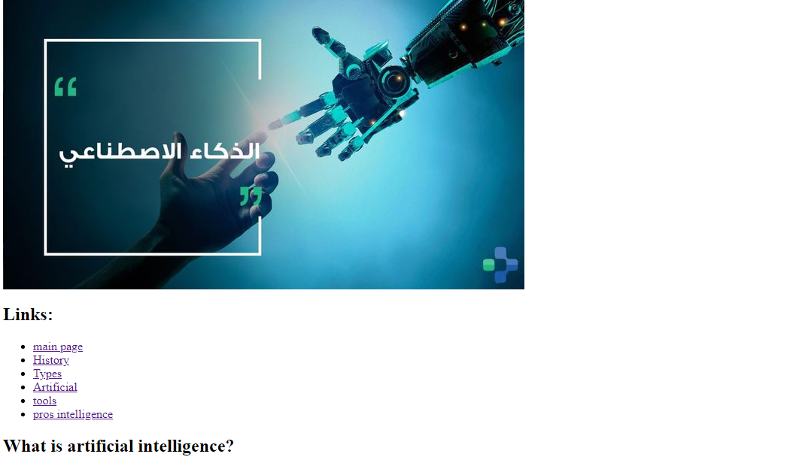

# Screenshots : main page code:

